Test Results:

UI development

Home Page

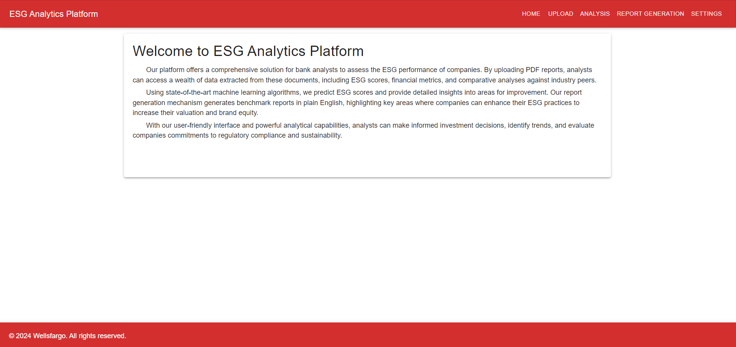

Upload Page

ESG Score Prediction Model in Azure ML Studio:

* Pipeline created in Azure ML studio for ESG Score prediction.

* Successfully trained the model with the given dataset.

* Pipeline is deployed to the real time inference and deployed on the AKS cluster.

* Tested the API and predicted ESG score for a company with below ESG indicators.

